Project Title: Coastal Building Supplies
Description: Construction of a New Building Supplies Depot
Client: Coastal Building Supplies Ltd
Value: £0.69M
Duration: 6 Months

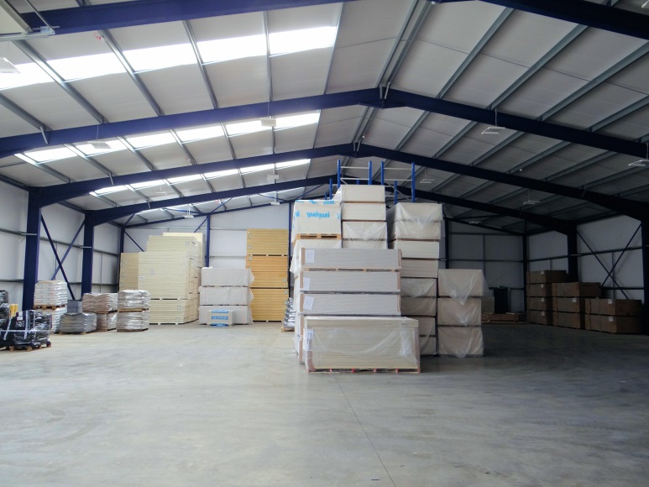
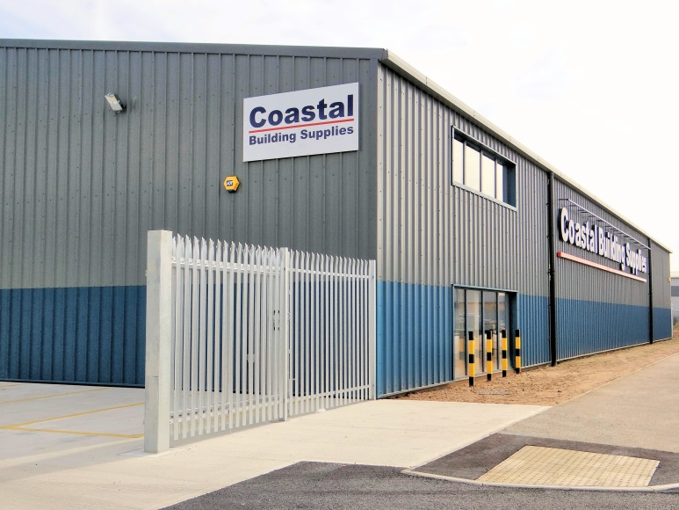

The project consisted of a 10,000ft² steel framed, fully clad, building supplies depot, incorporating retail space, warehousing, offices and welfare facilities. Construction methods included concrete pad foundations, laser poured concrete floor slab, composite cladding, aluminium framed window and doors and associated external works.

Client Testimonial:

"I would like to express my thanks to the team at Mixbrow for the completion of a successful contract. From beginning to end, Mixbrow have always been professional, timely and reliable. The project has been finished ahead of time, within budget. Workmanship and attention to detail have been of a very high standard, with exemplary site management. Should we have need of a contractor in the future I would be pleased to work with you again. Please pass my thanks to all involved." John Parish, Chairman, Coastal Building Supplies Ltd.

