Project Title: The Belvedere, Lime Kiln Key, Woodbridge, Suffolk
Description: Office Accommodation and Holiday Let Apartments
Client: Robertson’s Boat Yard
Value: £0.7M
Duration: 10 Months

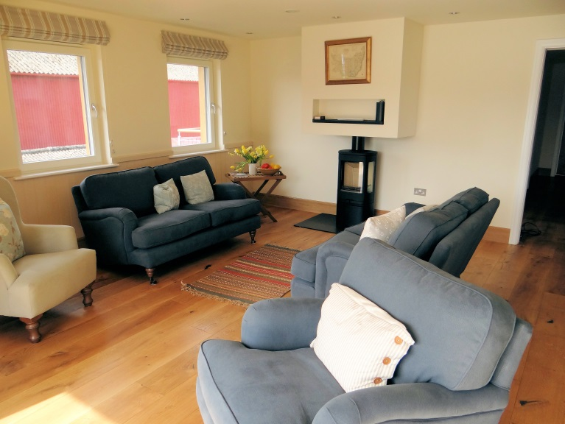
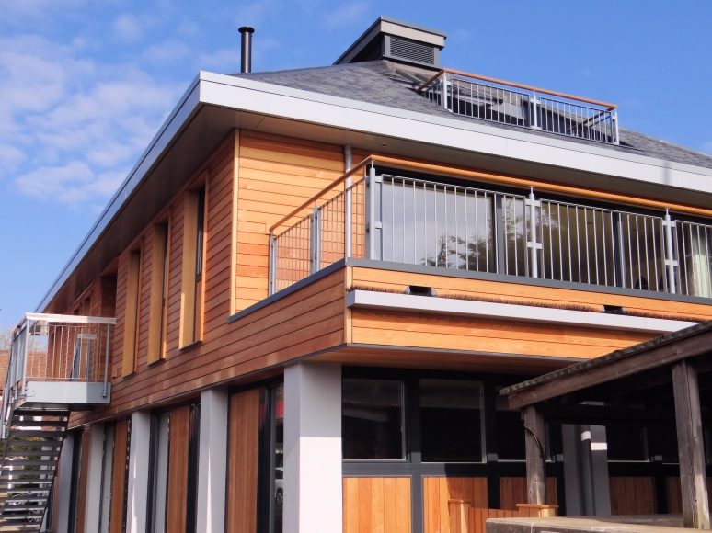

The project involved site clearance and demolition works, followed by the construction of a steel framed, three storey building. Accommodation incorporates ground floor office space with holiday let apartments to the first and second floors. Construction methods include CFA piled foundations, pre-cast concrete floors, natural slate roof covering, through-colour render, composite window and doors and Siberian Larch cladding. First and second floor balconies provide picturesque views across the river Deben.

Client Testimonial:

"We are delighted with our new building, which is a complex and unique design. Mixbrow did exactly what they promised, delivering it on time and budget. They are a professional organisation, with a personal approach to problem solving and construction." Clive F. Eminson BSc FRICS, Chairman, Robertson’s Boatyard.

