Project Title: North Meadow Cottage, Mendham Mill, Suffolk
Description: Conversion, Alteration and Extension of a Redundant Building to form a Holiday Let Property
Client: Mr James Johnston
Value: £0.28M
Duration: 5 Months

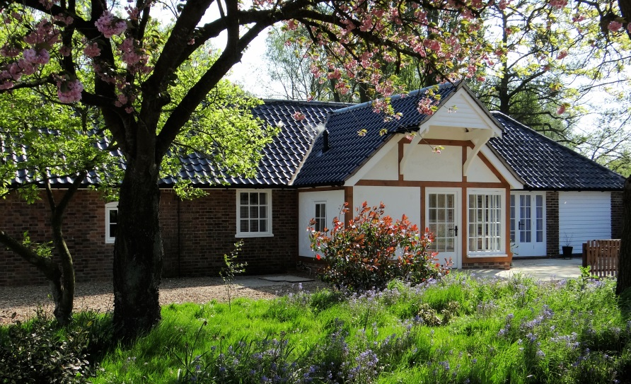
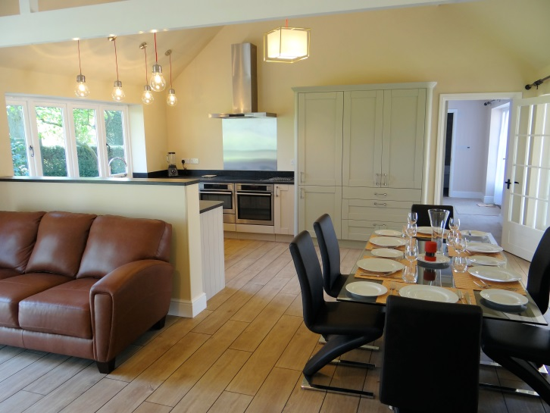

The building was stripped back to a shell and sympathetically renovated to produce an attractive holiday let property. The feeling of space and airiness was enhanced by the creation of vaulted ceilings and the installation of aluminium sliding / folding doors.

An open plan design and incorporation of modern features, such as underfloor heating and a wheelchair accessible wet room maximises usability. Bespoke softwood windows and pargetting are in-keeping with the surrounding buildings

Client Testimonial:

“I employed Mixbrow to convert and existing outbuilding to create a 3 bedroom house in challenging conditions. My site was demanding; in the grounds of an historic watermill, with a high water table. Relations between Mixbrow and me were excellent throughout. Mixbrow staff and their subcontractors were always cheerful and helpful – willing to explain what they were doing. Everyone working on the project seemed determined to build to the highest specification and the finished result is excellent. James Johnston, Mendham Mill.

